NAME: DHAMODHARAN M

1. **Do the below programs in anonymous function & IIFE**
   1. **Print odd numbers in an array**

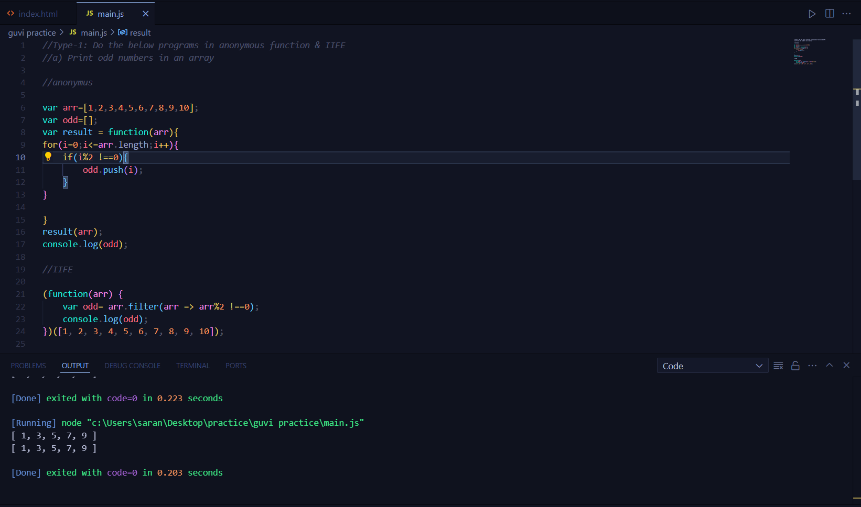

**b. Convert all the strings to title caps in a string array**

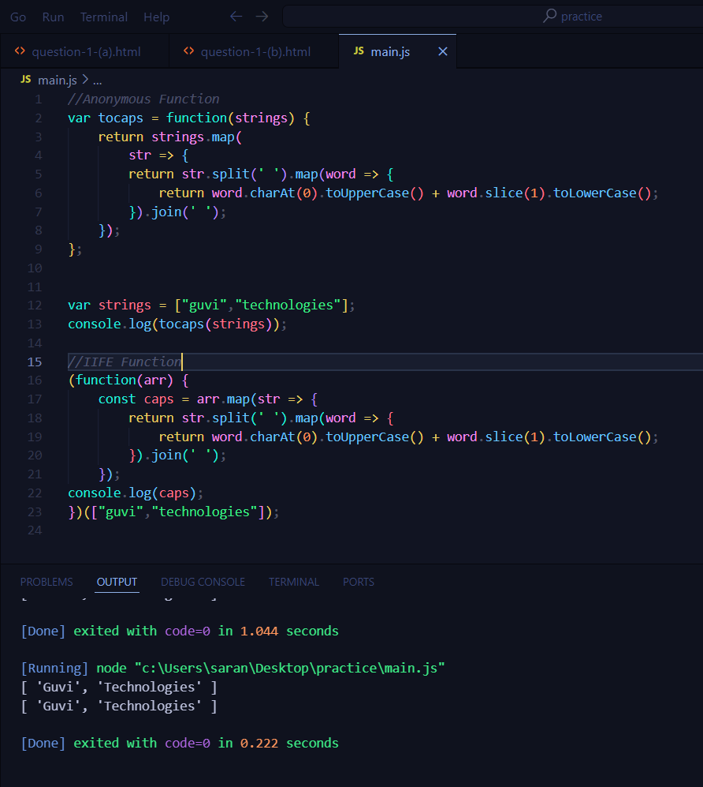

1. **Sum of all numbers in an array**

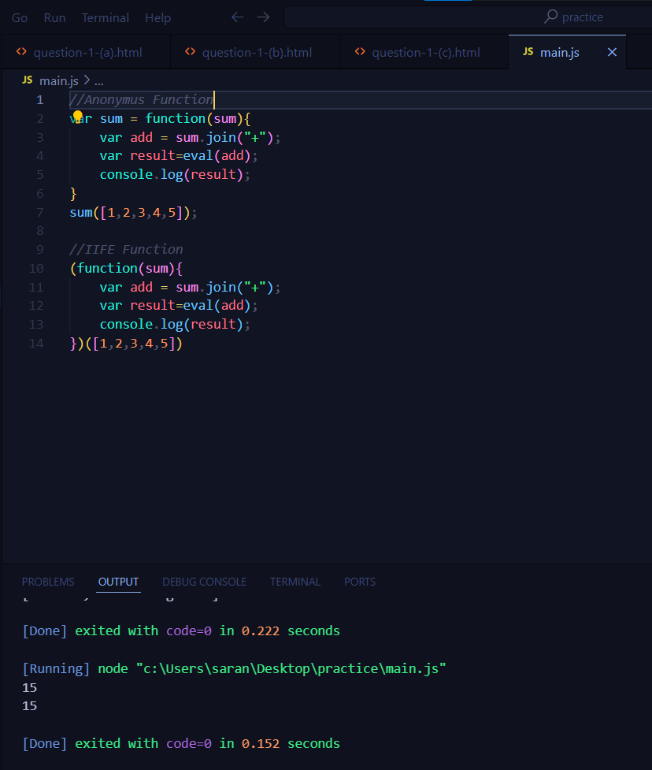

1. **Return all the prime numbers in an array**

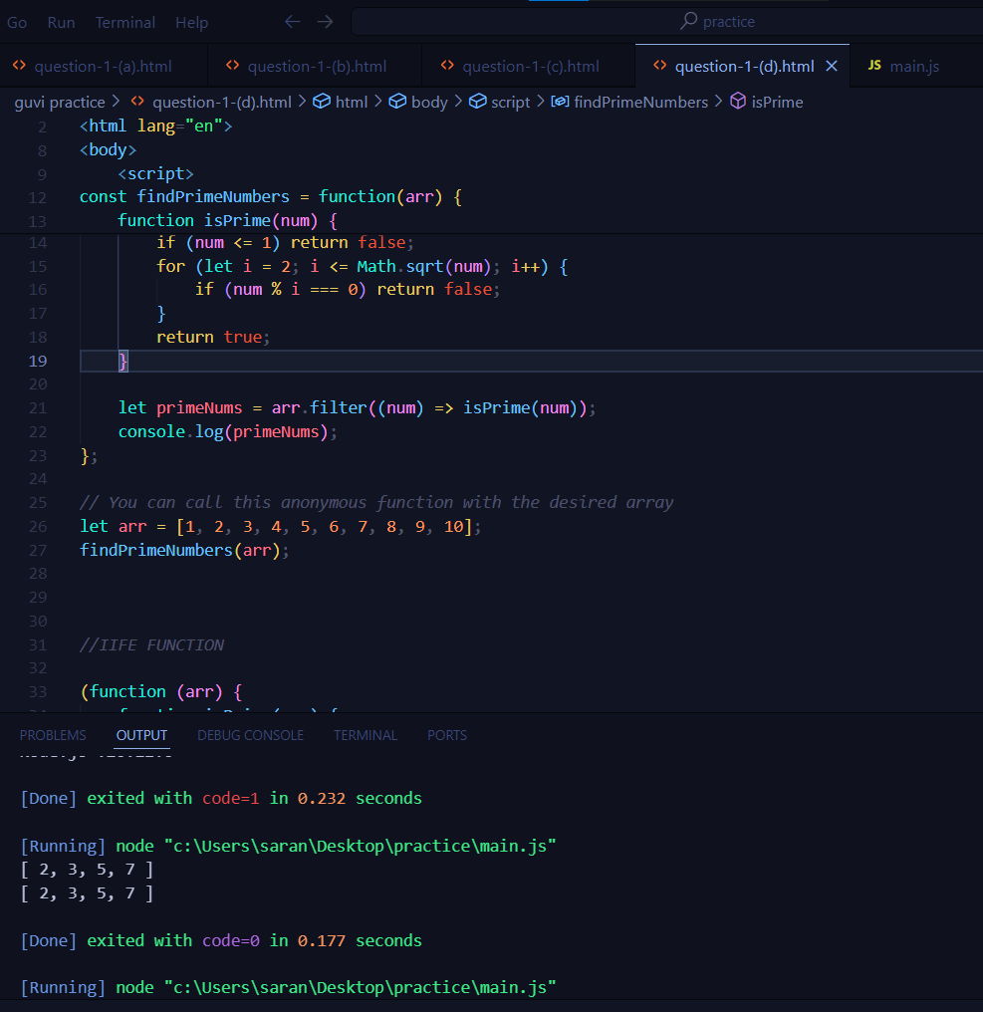

1. **Return all the palindromes in an array**

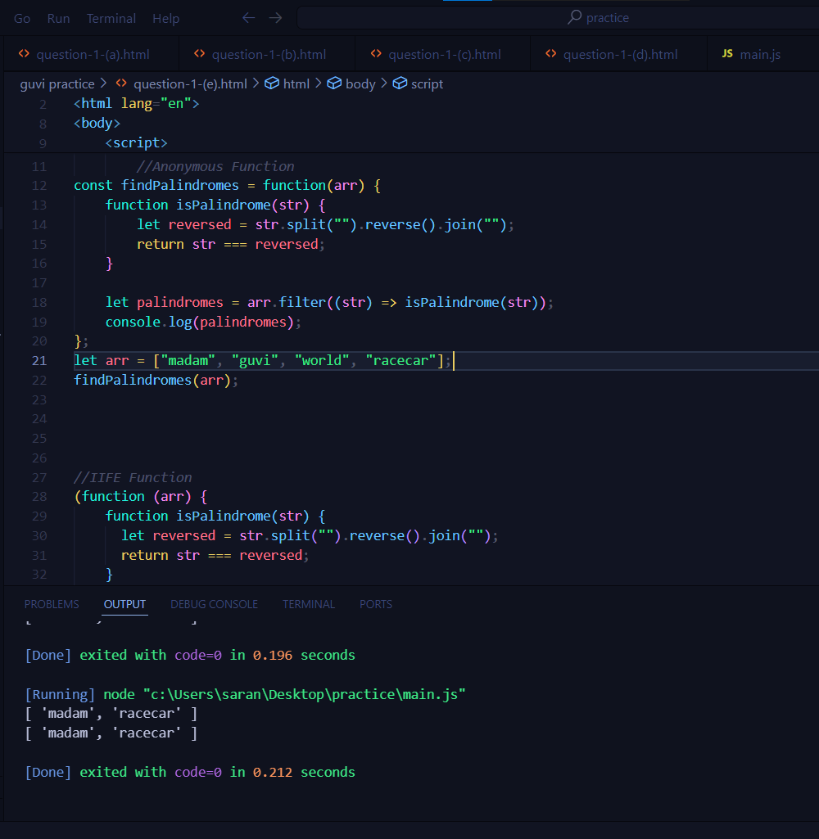

1. **Return median of two sorted arrays of the same size.**

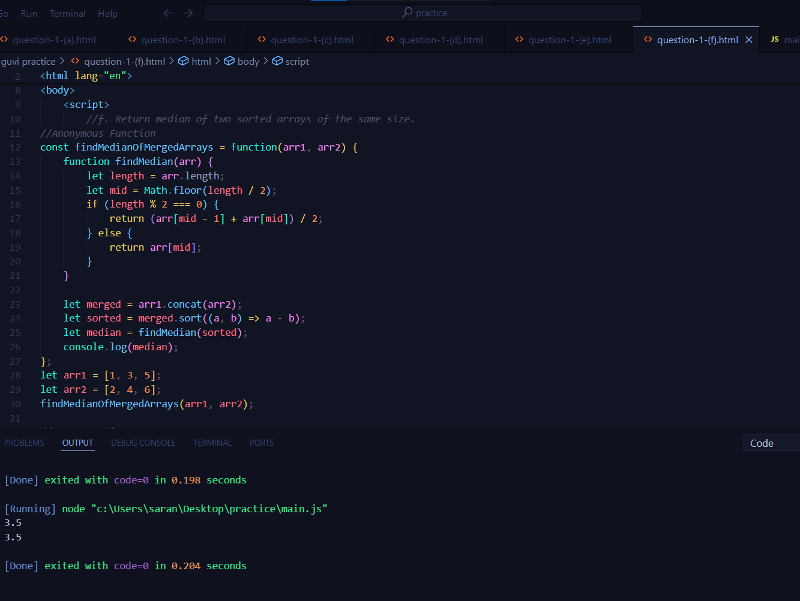

1. **Remove duplicates from an array**

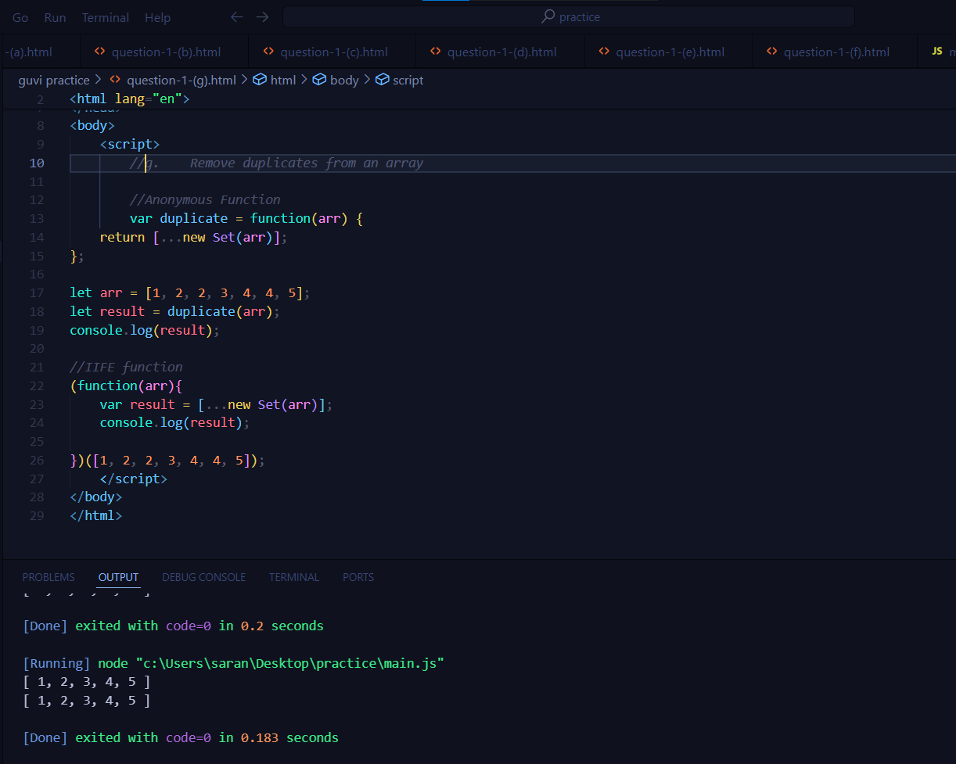

1. **Rotate an array by k times**

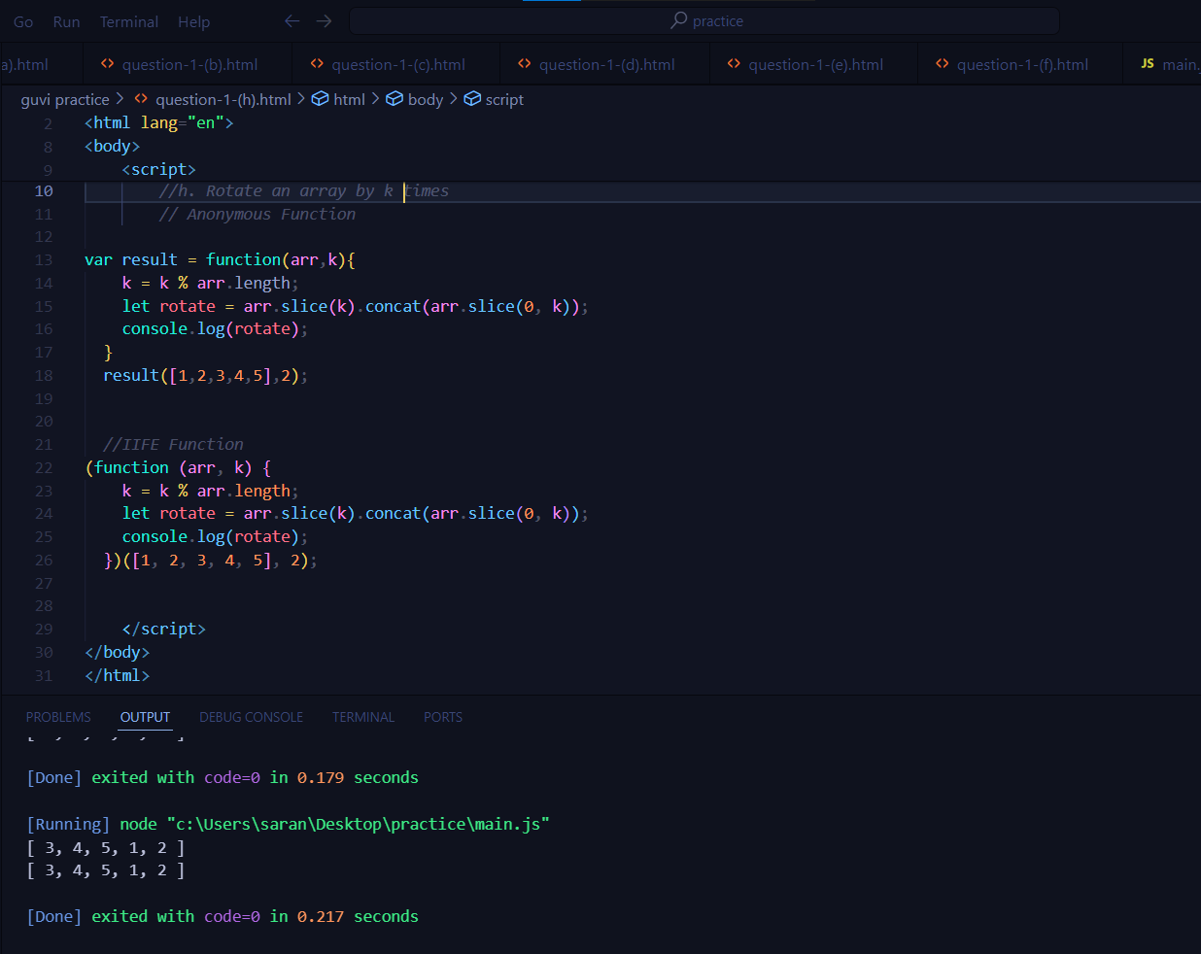

1. Do the below programs in arrow functions.
2. Print odd numbers in an array
3. Convert all the strings to title caps in a string array
4. Sum of all numbers in an array
5. Return all the prime numbers in an array
6. Return all the palindromes in an array

